**Process Management**

**What is a Process?**

An instance of a program is called a Process. In simple terms, any command that you give to your Linux machine starts a new process

**Types of Processes in Linux**

**Foreground Processes (fb)**

They run on the screen and need input from the user.

For example Office Programs

**# fg**

**Background Processes(bg)**

They run in the background and usually do not need user input.

For example Antivirus.

**# bg**

To list the processes

**# top**

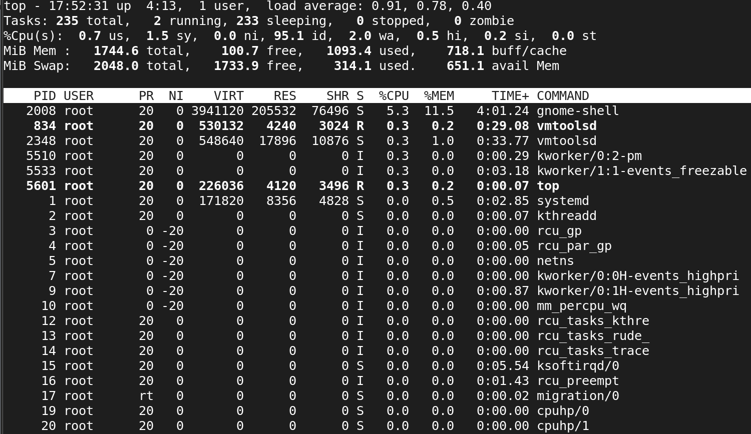

To list all the process of all user with parent process id

**#ps ­efa**

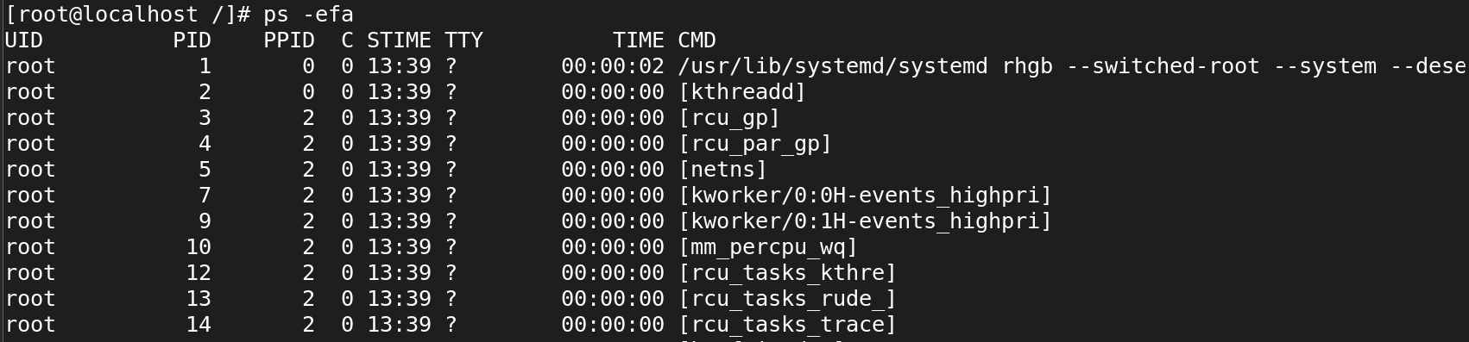

**#ps -ef**

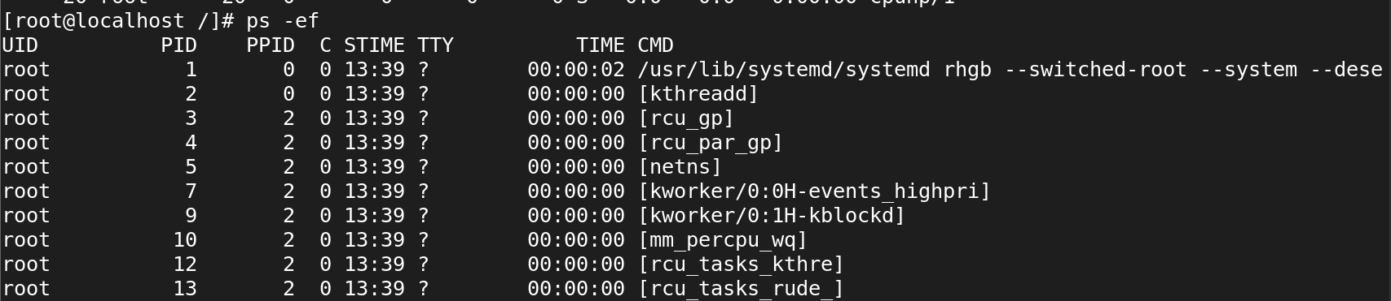

To list all running processes

**# ps ­aux**

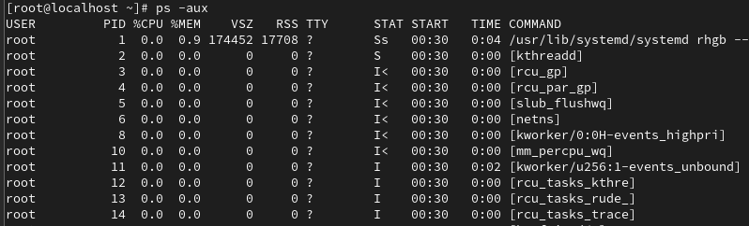

To list a specific user's processes **#ps ­u username**

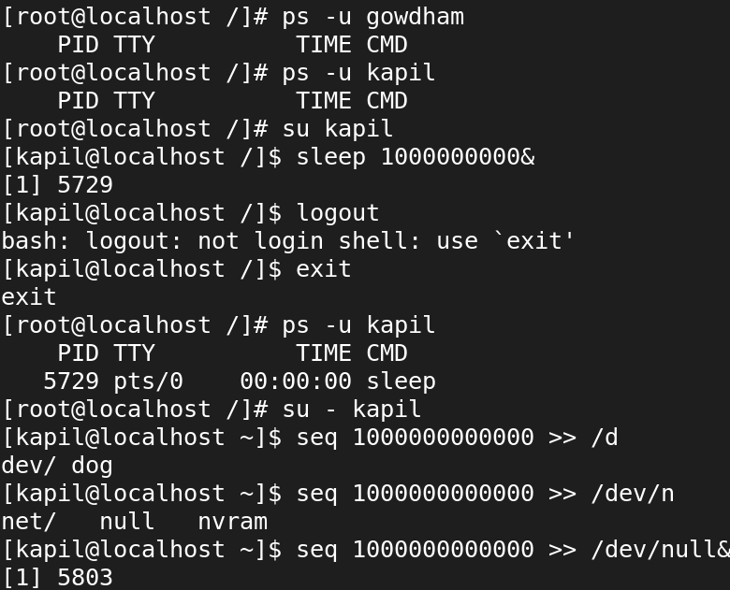

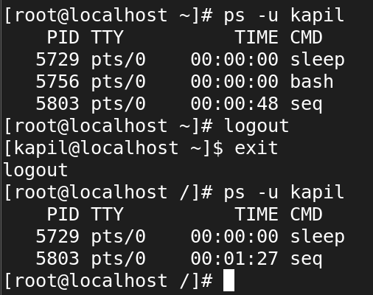

**Options for viewing the task**

**#ps**

**-a 🡺** Shows information about all users.

**-x 🡺** Shows information about processes without terminals.

**-e 🡺** Displays extended information.

**-u 🡺** Shows additional information like -f option.

**Parent process:**

* In Linux all the processes have a parent process. When the user creates a process in that case the kernel process becomes the parent of that process.
* Every Linux process has two ID's assigned to it, the Process ID (pid) and the Parent process ID (ppid).

**Child Processes:**

* The processes which gets created by another process it'ns parent process known as child process.
* In our above example, the sleep process with PID 1971 is a child process of the bash process with PID 1589.

**Daemon process:**

* The system related background running processes are called Daemon Processes.
* When you see a process running with a ? mark in sixth column (TTY field), that's a daemon process.

**Zombie processes:**

* At times there are processes which are already dead but still shows up in process list are called Zombie processes.
* These processes can be found while doing ps listing, the process with a Z state are zombie processes.
* They don't consume any CPU resources.

**The process status can be any of the following:**

* R: Running
* S: Sleeping
* D: Uninterruptible sleep
* T: Traced (stopped state)
* Z: Zombie

R 🡺 Running process which is executed on cpu.

S 🡺 Sleeping or waiting process. This process is in waiting stage for a signal.

D 🡺 Uninterruptable. This process is in sleeping process which will not respond to a signal.

T 🡺 Stopped process or suspended process. This process can be continued by another signal to return to running process.

Z 🡺 Zombie process. This is a child process sending its parent process an exit signal.

**TASK STATUS**

TASK_RUNNING(R) 🡺task (process) currently running

TASK_INTERRUPTABLE (S) 🡺 process is sleeping but can be woken up (interrupted)

TASK_UNINTERRUPTABLE(D) 🡺 process is sleeping but can not be woken up (interrupted)

TASK_ZOMBIE(Z) 🡺 process terminated but its status was not collected (it was not waited for)

TASK_STOPPED(T) 🡺 process stopped by a debugger or job control

**# su - gowdham**

**# ps ux**

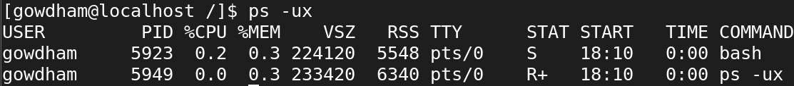

**ps -ux** is useful for monitoring user-specific processes, providing a snapshot that helps in managing and debugging processes in a system.

**#ps f**

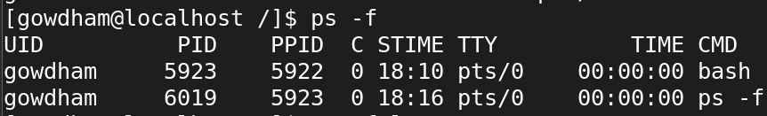

**#ps -f 1**



**#pidof**

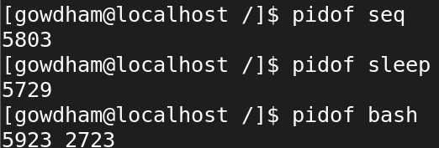

**# pgrep sshd**



**# pgrep -l sshd**

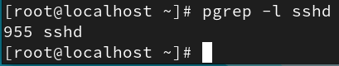

**# pkill sleep**

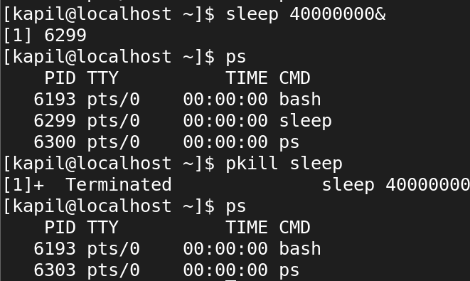

**# ps -u kapil**

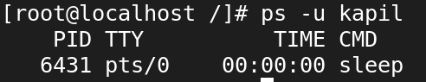

To kill all the process

**# killall**

To kill imediately

**# kill -l**

To kill slowly

**# kill -9**

**Scheduling Priorities**

* Every process has scheduling priorities.
* The value which is assigned for scheduling the priorities is called "NICE VALUE"
* Nice value range is -20 to 19
* The default nice value of a process is 0.
* High nice value process means low CPU usage.(19)
* Low nice value means High CPU usage.(-20)
* The root user can increase or decrease the priorities of a process.
* The normal user can only increase the priority of a process.

**To schedule priorities.**

**1) For running process**

**# renice <nicevalue> PID**

# renice 9 3803

**2) For new process**

**# nice ­n nicevalue command**

**# nice -n -20 seq 100000000000000000000 > /dev/null**

**Field**

**# top**

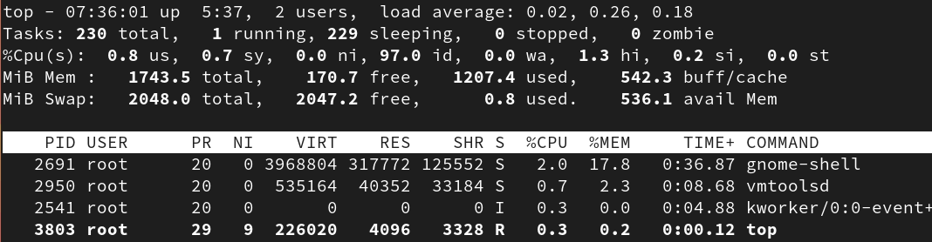

PID 🡺 Process ID.

USER 🡺 The owner of the process.

PR 🡺 Process priority.

NI 🡺 The nice value of the process.

VIRT 🡺 Amount of virtual memory used by the process.

RES 🡺 Amount of resident memory used by the process.

SHR 🡺 Amount of shared memory used by the process.

S 🡺 Status of the process. (See the list below for the values this field can take).

%CPU 🡺 The share of CPU time used by the process since the last update.

%MEM 🡺 The share of physical memory used.

TIME+ 🡺 Total CPU time used by the task in hundredths of a second.

COMMAND 🡺 The command name or command line (name + options).

**Changing the Summary Contents - l,1,t,m**

k - Kill a Process

z - Color and Highlighting

F - used to select the heading show in top command

**Sorting by Columns**

P 🡺 The %CPU column.

M 🡺 The %MEM column.

N 🡺 The PID column.

T 🡺 The TIME+ column.

**Options on top**

c - See the Full Command Line

u - See Processes for a Single User

n - Set How Many Processes to Display

r - Renice a Process

d or s to change the delay time

**# uptime**



**# w**



**# free -h**

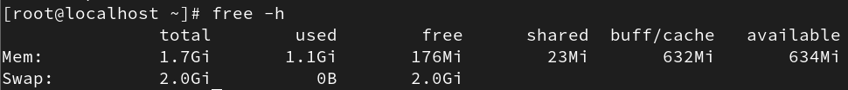

**# df -h**

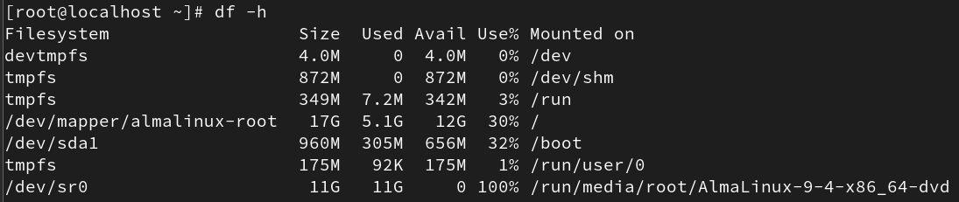

**# cat /proc/cpuinfo**

To see the cpu information

**# cat /proc/meminfo**

To view the memory info

**Check CPU core**

**# nproc**

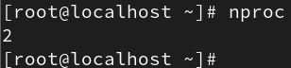

**# lscpu**

To view cpu info

**# top**

To view task

**Command Description**

bg 🡺To send a process to the background

fg 🡺To run a stopped process in the foreground

top 🡺Details on all Active Processes

ps 🡺Give the status of processes running for a user

ps 🡺PID Gives the status of a particular process

pidof 🡺Gives the Process ID (PID) of a process

kill PID 🡺Kills a process

nice 🡺Starts a process with a given priority

renice 🡺Changes priority of an already running process

df 🡺Gives free hard disk space on your system

free 🡺Gives free RAM on your system

**# top**



us: Amount of time the CPU spends executing processes for people in “user space.”

sy: Amount of time spent running system “kernel space” processes.

ni: Amount of time spent executing processes with a manually set nice value.

id: Amount of CPU idle time.

wa: Amount of time the CPU spends waiting for I/O to complete.

hi: Amount of time spent servicing hardware interrupts.

si: Amount of time spent servicing software interrupts.

st: Amount of time lost due to running virtual machines (“steal time”).